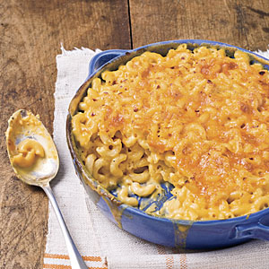Photo by: Photo: Beth Dreiling Hontzas; Styling: Melanie J. Clarke

**Classic Baked Macaroni and Cheese**

Whisk warm milk into the flour mixture to ensure a lump-free sauce. We also recommend shredding your own cheese for a creamier texture. We tested with Cracker Barrel Extra-Sharp Cheddar.

Southern Living OCTOBER 2009

* **Yield:** Makes 6 to 8 servings
* **Hands-on:**22 Minutes
* **Total:**47 Minutes

**Ingredients**

* 2 cups milk
* 2 tablespoons butter
* 2 tablespoons all-purpose flour
* 1/2 teaspoon salt
* 1/4 teaspoon freshly ground black pepper
* 1 (10-oz.) block extra sharp Cheddar cheese, shredded
* 1/4 teaspoon ground red pepper (optional)
* 1/2 (16-oz.) package elbow macaroni, cooked

**Preparation**

1. WHISK FLOUR INTO BUTTER

Preheat oven to 400°. Microwave milk at HIGH for 1 1/2 minutes. Melt butter in a large skillet or Dutch oven over medium-low heat; whisk in flour until smooth. Cook, whisking constantly, 1 minute.

2. WHISK IN WARM MILK

Gradually whisk in warm milk, and cook, whisking constantly, 5 minutes or until thickened.

3. WHISK IN CHEESE

Whisk in salt, black pepper, 1 cup shredded cheese, and, if desired, red pepper until smooth; stir in pasta. Spoon pasta mixture into a lightly greased 2-qt. baking dish; top with remaining cheese. Bake at 400° for 20 minutes or until golden and bubbly